COMSATS University Islamabad (CUI) Attock Campus

**C**

**Final Term**

**MUHAMMAD YAQOOB CIIT/FA21-BCS-044/ATK**

**Submitted To: Dr. Bilal Haider  
subject: CC**

**Question 4:**

Input:  
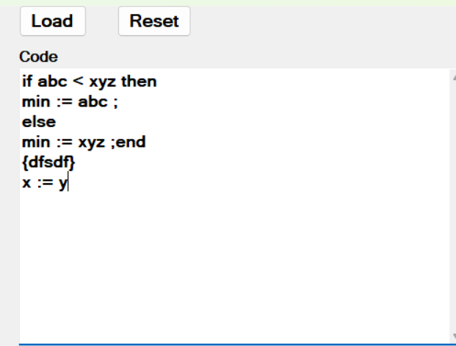

if abc < xyz then

min := abc ;

else

min := xyz ;

end

{dfsdf}

x := y

**Output:**

**After Scanning:  
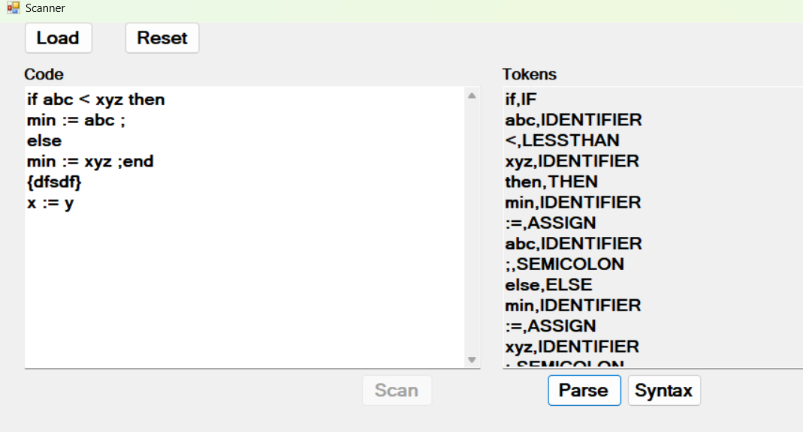**

**After Parsing:  
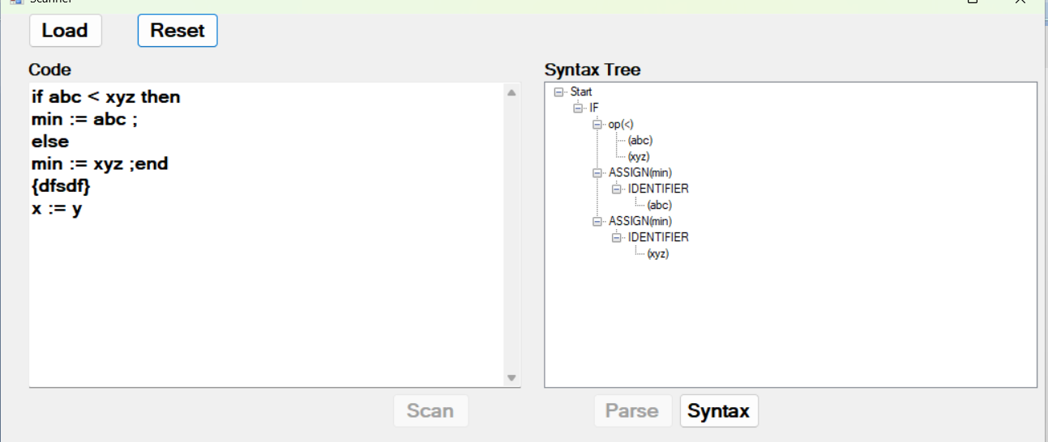**

**After Semantic Analysis:  
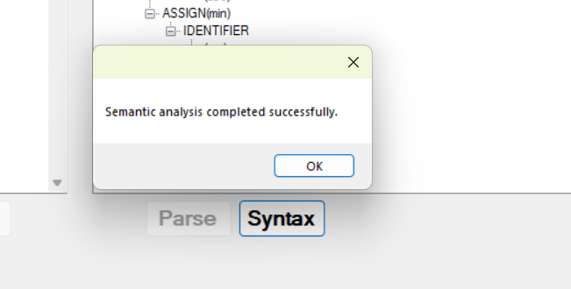**

**Otomization:  
